Ordering Epysqli (eculizumab)
Epysqli is available to order through Phoenix and Healthnet
- Follow your normal internal processes for ordering Epysqli (Eculizumab) via Healthnet using the ordering form or Phoenix via the Phoenix Gateway portal

Clinician: You will need to liaise with your pharmacist and they will order Epysqli.
Pharmacist: Process to order Epysqli:

Ordering via Phoenix
Please refer to the Phoenix Gateway Portal via the link to complete you Epysqli order - https://phoenixgateway.co.uk/login

For any queries around ordering with Phoenix please refer to the contact details below –
- Email anickson@phoenixmedical.co.uk
- Phone +44 7890 907 160, M: +44 7890 907 160)

Phoenix ordering timelines
☐ MEDICAL EMERGENCY SUPPLY | WITHIN 24 hours  (Inc Saturday, Sunday & Bank Holidays} | For emergency supply requests, please refer to the Phoenix emergency ordering guidance:  Ensure all emergency requests are clearly communicated as urgent when contacting the service line.
☐ NEXT WORKING DAY | Standard Business Hours (08.00–18.00 Monday to Friday) | Orders during standard business hours should be placed via Phoenix Gateway.  All orders received before 18.00 will be dispatched the same day for delivery the next working day.  Any orders received after 18.00 will be dispatched the following working day and will be delivered on next business day +1.  For guidance on placing an order via Phoenix Gateway, please refer to Phoenix Gateway Ordering Guide

Ordering via HealthNet
Please refer to the Healthnet Order Form
Email the order form to - eculizumab@healthnethomecare.co.uk to place your order.
Please call the 24-hour service line on 0113 340 1850 to log your request and confirm with the on-call Healthnet handlers that you have provided the full document set and core information requested. Failure to call this number will result in delayed medication delivery

Healthnet Ordering timelines -
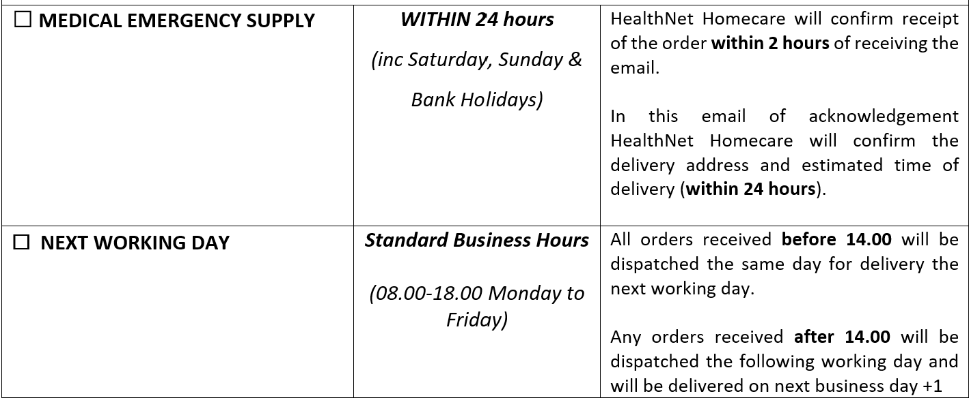

Ideally, for a next working day order, this should be done before 1400hrs on Mon-Thursday to guarantee next day delivery. Ordering Epysqli (eculizumab) when it is needed urgently (in active cases of aHUS), Samsung Bioepis have a process in place for emergency drug procurement which is funded and is free of charge to the NHS. You need to order as per the process above for both Phoenix and Healthnet

